Exercise 1: Configuring a Basic Spring Application
Spring Framework is a lightweight Java framework that simplifies application development by managing objects (beans) through the Inversion of Control (IoC) container. XML configuration allows developers to define and configure beans without changing the Java source code.

Code
1. pom.xml
<project xmlns="http://maven.apache.org/POM/4.0.0"
xmlns:xsi="http://www.w3.org/2001/XMLSchema-instance"
xsi:schemaLocation="http://maven.apache.org/POM/4.0.0
https://maven.apache.org/xsd/maven-4.0.0.xsd">
<modelVersion>4.0.0</modelVersion>
<groupId>com.library</groupId>
<artifactId>LibraryManagement</artifactId>
<version>1.0-SNAPSHOT</version>
<dependencies>
<dependency>
<groupId>org.springframework</groupId>
<artifactId>spring-context</artifactId>
<version>5.3.39</version>
</dependency>
</dependencies>
</project>

2. applicationContext.xml
<?xml version="1.0" encoding="UTF-8"?>
<beans xmlns="http://www.springframework.org/schema/beans"
xmlns:xsi="http://www.w3.org/2001/XMLSchema-instance"
xsi:schemaLocation="
http://www.springframework.org/schema/beans
https://www.springframework.org/schema/beans/spring-beans.xsd">
<bean id="bookRepository"
class="com.library.repository.BookRepository"/>
<bean id="bookService"
class="com.library.service.BookService"/>
</beans>

3. BookRepository.java
package com.library.repository;
public class BookRepository {
public void displayRepository() {
System.out.println("BookRepository bean created successfully.");
}
}

4. BookService.java
package com.library.service;
public class BookService {
public void displayService() {
System.out.println("BookService bean created successfully.");
}
}

5. LibraryManagementApplication.java
package com.library.main;
import org.springframework.context.ApplicationContext;
import org.springframework.context.support.ClassPathXmlApplicationContext;
import com.library.repository.BookRepository;
import com.library.service.BookService;
public class LibraryManagementApplication {
public static void main(String[] args) {

ApplicationContext context = new ClassPathXmlApplicationContext("applicationContext.xml");
BookRepository repository = (BookRepository) context.getBean("bookRepository");
BookService service = (BookService) context.getBean("bookService");
repository.displayRepository();
service.displayService();
((ClassPathXmlApplicationContext) context).close();
}
}
Output
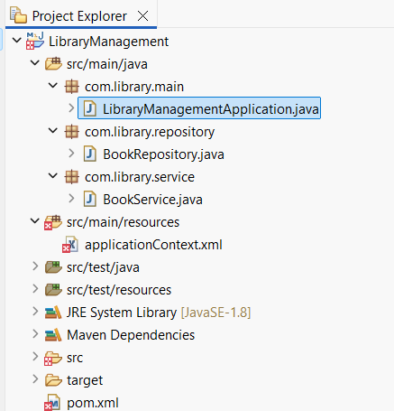
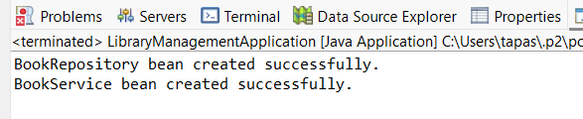
Result
The Spring application was successfully configured using Maven and XML-based bean configuration. The BookRepository and BookService beans were created and loaded through the Spring IoC container, demonstrating successful Spring Framework setup.

Exercise 2: Implementing Dependency Injection
Dependency Injection (DI) is a feature of the Spring IoC container that automatically provides the required dependencies to an object. Setter Injection is a type of DI where dependencies are injected using setter methods, making the application loosely coupled and easier to maintain.

Code
1. BookRepository.java
package com.library.repository;
public class BookRepository {
public void displayRepository() {
System.out.println("BookRepository bean created successfully.");
}
}

2. BookService.java
package com.library.service;
import com.library.repository.BookRepository;
public class BookService {
private BookRepository bookRepository;
public void setBookRepository(BookRepository bookRepository) {
this.bookRepository = bookRepository;
}
public void displayService() {
System.out.println("BookService bean created successfully.");
bookRepository.displayRepository();
}
}

3. applicationContext.xml
<?xml version="1.0" encoding="UTF-8"?>
<beans xmlns="http://www.springframework.org/schema/beans"
xmlns:xsi="http://www.w3.org/2001/XMLSchema-instance"
xsi:schemaLocation="
http://www.springframework.org/schema/beans
https://www.springframework.org/schema/beans/spring-beans.xsd">
<!-- BookRepository Bean -->
<bean id="bookRepository"
class="com.library.repository.BookRepository"/>
<!-- BookService Bean with Dependency Injection -->
<bean id="bookService"
class="com.library.service.BookService">
<property name="bookRepository" ref="bookRepository"/>
</bean>
</beans>

4. LibraryManagementApplication.java
package com.library.main;
import org.springframework.context.ApplicationContext;
import org.springframework.context.support.ClassPathXmlApplicationContext;
import com.library.service.BookService;
public class LibraryManagementApplication {
public static void main(String[] args) {
ApplicationContext context =
new ClassPathXmlApplicationContext("applicationContext.xml");
BookService service = (BookService) context.getBean("bookService");
service.displayService();
((ClassPathXmlApplicationContext) context).close();
}
}
Output
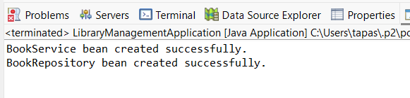
Result
The Spring application successfully implemented Setter-Based Dependency Injection using XML configuration. The BookRepository bean was injected into the BookService bean through the Spring IoC container, and the application executed successfully with the expected output.

Exercise 4: Creating and Configuring a Maven Project

Apache Maven is a build automation and dependency management tool that simplifies Java project development by managing libraries through the pom.xml file. The Maven Compiler Plugin is used to specify the Java version for compiling the project source code.

Code
pom.xml
<project xmlns="http://maven.apache.org/POM/4.0.0"
xmlns:xsi="http://www.w3.org/2001/XMLSchema-instance"
xsi:schemaLocation="http://maven.apache.org/POM/4.0.0
https://maven.apache.org/xsd/maven-4.0.0.xsd">
<modelVersion>4.0.0</modelVersion>
<groupId>com.library</groupId>
<artifactId>LibraryManagement</artifactId>
<version>1.0-SNAPSHOT</version>
<dependencies>
<!-- Spring Context -->
<dependency>
<groupId>org.springframework</groupId>
<artifactId>spring-context</artifactId>
<version>5.3.39</version>
</dependency>
<!-- Spring AOP -->
<dependency>
<groupId>org.springframework</groupId>
<artifactId>spring-aop</artifactId>
<version>5.3.39</version>
</dependency>
<!-- Spring Web MVC -->
<dependency>
<groupId>org.springframework</groupId>
<artifactId>spring-webmvc</artifactId>
<version>5.3.39</version>
</dependency>
</dependencies>
<build>
<plugins>
<!-- Maven Compiler Plugin -->
<plugin>
<groupId>org.apache.maven.plugins</groupId>
<artifactId>maven-compiler-plugin</artifactId>
<version>3.11.0</version>
<configuration>
<source>1.8</source>
<target>1.8</target>
</configuration>
</plugin>
</plugins>
</build>
</project>

Result
The Maven project was successfully created and configured. The required Spring Framework dependencies (spring-context, spring-aop, and spring-webmvc) were added to the pom.xml, and the Maven Compiler Plugin was configured to compile the project using Java 1.8, enabling the project to build and manage dependencies successfully.

